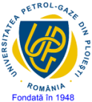
Annex 8

MINISTRY OF EDUCATION
PETROLEUM-GAS UNIVERSITY OF DIN PLOIEŞTI

FACULTY: ………………………………………………
DEPARTMENT: …………………………………………………………………..
STUDY PROGRAM: ……………………………………………………………………………….
FORM OF EDUCATION: F

Approved  Faculty ................  (signature and stamp) | Aprobat,  Departament Director,

MASTER THESIS
Title:

Scientific coordinator:

Graduate:

PLOIEŞTI
202..

